**Using Hyper-terminal to communicate with DE1 Board**

* Install the Hyper-terminal software on your PC/Laptop.
* Plug a USB cable into your laptop and the other end into the “USB to RS232 converter dongle” supplied by your instructor. Windows should install the driver automatically.
* Using the supplied ribbon cable, connect the **ground**, **TX** and **RX** pins from the dongle to the GPIO 1 port on the DE1 (see below).

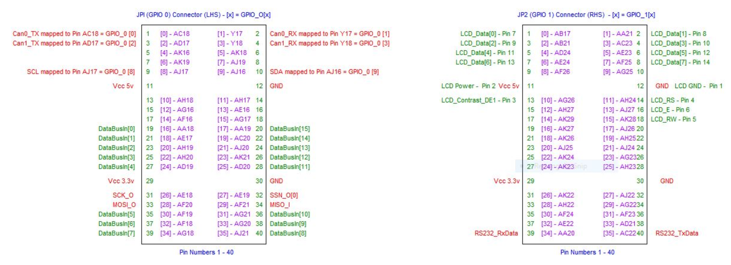

**Note 1**: The **DONGLE** is powered via the USB Port from your Laptop, so **ONLY** needs a **common ground** connection to the DE1 board.

**Note 2**: When connecting the Dongle to the DE1 using the ribbon cable that you have to swap the TX/RX pins between DE1 and Dongle. That is the TxData pin on the DE1 connects to the Rx pin on the dongle and vice versa - (a very common arrangement for Serial port, i.e. Transmit out connected to Receive in)

**How do I know if the Windows driver has installed?**

Windows should tell you if it installed the driver, if it was Unsuccessful you will see the image below when you click on :- Computer->Manage->Device Manager. Note the yellow ‘!’ next to unknown device below

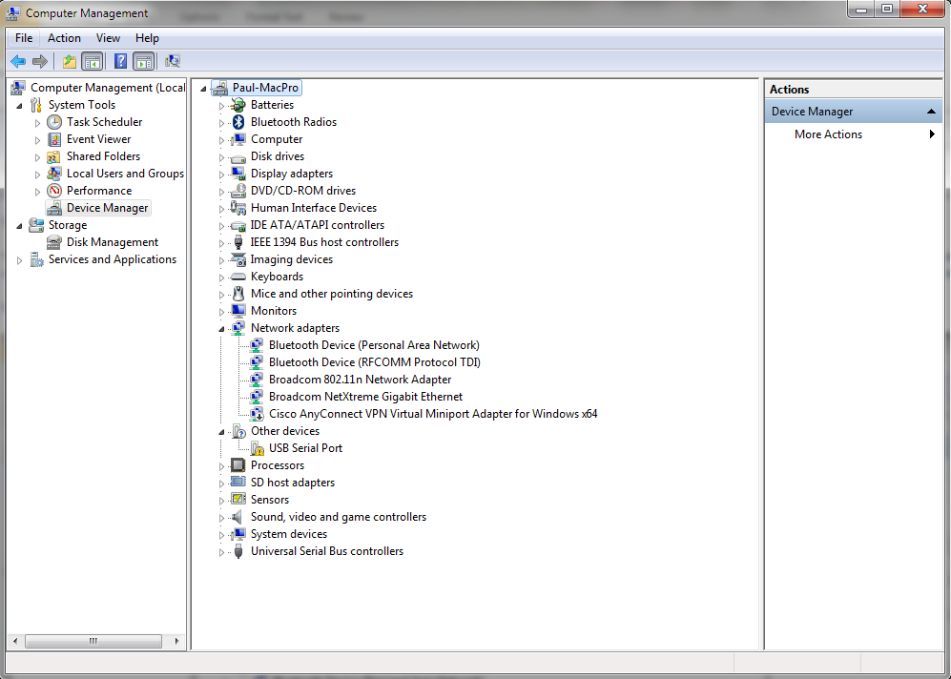

If you **don’t** see **any device** appear, then the dongle may be faulty so you should have it checked/replaced from where you got it.

**Installing a Driver Manually (*skip if the driver installed automatically*)**

If the driver did not install automatically go to control panel and make sure windows update is turned on as shown below

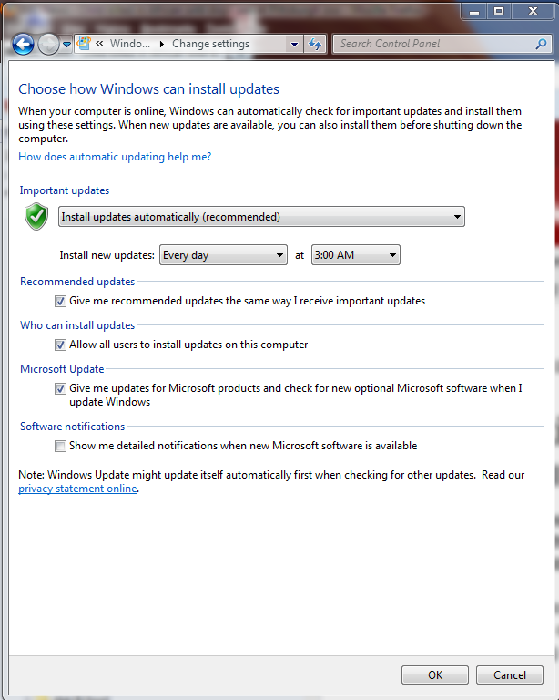

Close the control panel and return to the Computer->Manage->Device Manager window.   
Now right mouse click on the uninstalled device and select “Update Driver Software”. This window should appear. Click the search automatically, (including the internet) for the latest drivers. This should take up to a minute or so (if it takes just a few seconds, the internet is **not** being searched and thus it will fail as the driver is not included in the normal Windows installation).

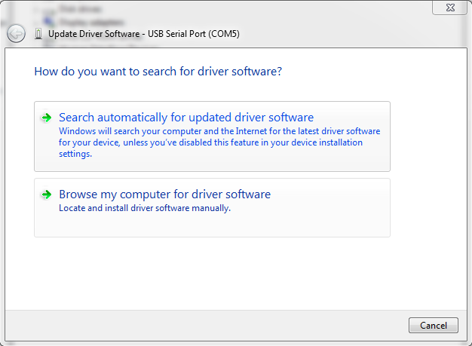

If all of this works, a driver should be loaded and you should see your new device like this appear with a name like COM5 (or something similar – the number may vary).

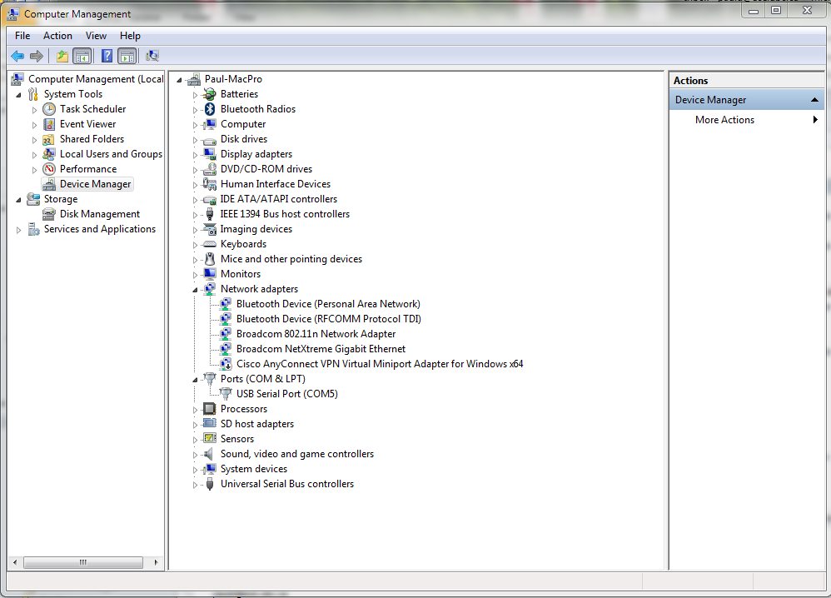

If this **doesn’t work** or windows cannot locate the driver, you can download the driver from the course web site, (it’s a CH341SER.ZIP file which you will need to extract to somewhere on your disk).

You can right click on the uninstalled device as before and instead of telling windows to search the internet, click on browse my computer and point it to the driver you unzipped.



**Starting Hyper-terminal**

* When you start Hyper-terminal – the following screen appears – Type de1 into the Connection Description (the name is not important, but you have to give one). Click OK.

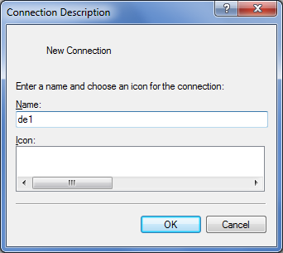

The following will appear asking you to connect via a “virtual” COM3 (or similar) serial port on your PC. **If you don’t get this and it asks for a TCP/IP (Winsock) connection it is because you either don’t have your USB-RS232 converter plugged in to your laptop, or the driver for it has not been installed**. See earlier section above for installing the driver.

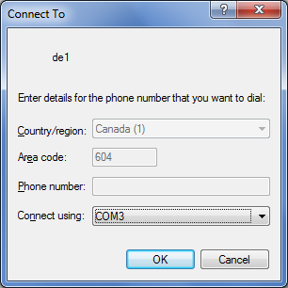

Click **OK** – The following will appear

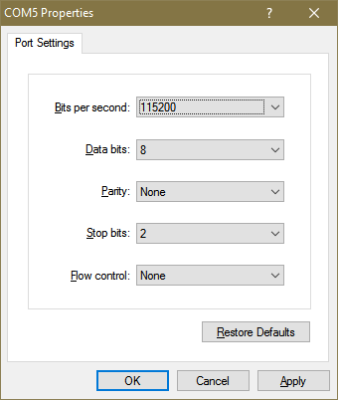

Configure the Port settings exactly as shown above, 115200 Bits per second, 2 stop bits and Flow control = none, then Click **OK**

You should have the following virtual terminal connection to the DE1 board which allows you to communicate with it using your Laptop.

If you have programmed (flashed or downloaded) your DE1 with a working 68000 system (i.e. the “.sof” file you downloaded from the course web site, you should see a ‘**#**’ prompt when you press the reset on the DE1 board (blue push button 1 – bottom right). **Make sure the left most two slider switches are in the down position.**

If you hit return you will see the screen below (or similar) that shows that you are communicating with a debug monitor **Note**: the debugger command summary changes from time to time depending on Version – this is V1.74. The debug Monitor allows you to load, run, debug and store your own programs into flash memory.

